Flow View

Software Functional Requirements

Document Classification:

Rev No. | Classification | Date
A | Internal Only - Proprietary and Confidential | 7/21/2015

Document Revision History:

Rev No. | Description | Originator | Approvals | Date
A | Initial revision | B Harris |  | 7/21/2015

Signatures:

Date | Title | Signature | Comments
 | Lead Engineer
 | Product Manager
 | Project Manager
 | Eng Ops Mgr
 | Director R&D

No table of contents entries found.

- Introduction
  - Objectives
    - This document outlines the functional requirements for the Timpanogos Flow View Software and User Interface elements.
  - Intended Audience
      - This document is provided for Engineering staff that will implement the Timpanogos Flow View Software.

  - Document Conventions
    - The following keywords (always defined in capitalized letters) are used within this document to describe requirements associated with the implementation of a specific feature:
      - MUST – (or the equivalent words “SHALL”, or “REQUIRED”) mean that the feature described is an absolute requirement of the specification.
      - MUST NOT – (or the equivalent words “SHALL NOT”) means that the definition is an absolute prohibition from the specification.
      - SHOULD – (or the equivalent adjective “RECOMMENDED”) means that there may exist a valid reason to ignore this element of the specification. However, the choice to ignore this element of the specification must be documented in the implementation specification.
      - SHOULD NOT – (or the equivalent adjectives “NOT RECOMMENDED”) means that there may exist circumstances in which implementation may be justified although the specification suggests otherwise. In these cases, the implementation must be justified and documented in the implementation specification.
      - MAY – (or the equivalent adjective “OPTIONAL”) signifies an element or feature which can be implemented at the discretion of the implementer. If implemented, justification must be documented in the implementation specification.
  - Definitions, Acronyms and Abbreviations
    - This section provides detailed description of all definitions, acronyms and abbreviations used in this document.
    - (Audio) Channel
      - A Channel refers to an object that generates, modifies or consumes an audio signal. In the case of Stereo there are 2 Channels, one for the “Left Channel” and one for the “Right Channel.”
    - Matrix Cross-point & Flow-View Route
      - The Matrix view is used to route a selected channel to 1 or more channels, or locations. A cross point is equal to a line in the FlowView. Note: The cross-point is represented as a cell in a 2 dimensional array (similar to a spread sheet) that can contain multiple attributes. It will be necessary to allow the user to see these attributes associated with a Route/Line in the FlowView.
    - Property / Setting
      - A user customizable value that represents a selectable or definable attribute used to achieve a desired result.
- High Level Requirements
  - Overview
    - To create a graphical GUI control/view of all audio channels within the system, depicting both processing and routing between end points and processing blocks. This view will be used to illustrate the current state of the device as well as stored (remember) configurations.
  - General Requirements
    - The following sections outline the general software functional requirements for the software.
    - Objective
      - Illustrate in a left to right orientation the "flow" of audio signals from "source" end-points (left edge), through optional processing locations/objects, to "destination" end-points. This view is interactive and allows the user to inspect and modify all properties, routes, etc.

    - Supported Operating System
      - The software MUST be supported under the Microsoft Windows 7, Windows 8, and Windows 10 (both 32 and 64 bit) OS platforms.
      - The software MAY also be supported under MAC OSX at some future date.
    - Real-Time performance
      - There can be no significant delays for the User when interacting with a Flow view containing 1000 nodes.
  - Rendering
    - The Figures below illustrate initial thoughts for the rendering of channels, Location/Objects, and Routes/Lines in the FlowView
    - FlowView Location/Object
      - A Location or Object is displayed as a “unit” (square, circle, etc.) in the FlowView where a specific type of processing occurs. These objects will have a unique identifier and processing properties which the User can customize to achieve the desired result.
      - End Points and Processing Blocks are FlowView Locations/Objects. These Objects may have either or both “incoming” and/or “outgoing” channels.
    - FlowView Line/Route (Matrix Crosspoint)
      - Routing is specifying the path a channel (signal) takes as it passes from an end-point/processing block to another.
        - A Route contains the following attributes/properties:
          - A. Type
          - B. Attenuation
          - C. Enable/Disable
          - Note: GUI must illustrate these properties in the rendering, via line styling.
    - End Points
      - An end point represents the end of a Channel: 1) Origin of a channel within the system (Microphone, Telco line in, etc.), or 2) termination point of a channel (Speaker, Telco line out, etc.). In the flow view these are object that have either an “outgoing” or an “incoming” channel connector, but not both.
    - Processing Block
      - Flow View objects that contain both incoming and outgoing channel routing connectors. In addition, this object also provides well defined processing on the channel(s) as they “flow through” the processing block. There are two types of processing blocks: Submix & Fader. (In the future there may be more.)
    - Input/Output (End Point) Groups
      - Groups are a named list of 1 or more homogeneous objects of either source or destination end points.. The Group object needs to be illustrated in the illustration, and are illustrated in Figures 2 and 5 (input object groups). The input object group has been added to the left of the input objects, and the output object group should be added to the right of the output group objects. The relationship of the objects to the groups is illustrated by a Line.
  - User Interaction
    - Required
      - The Graphical User Interface serves the following purposes for the TIMPANOGOS FLOW VIEW Software:
        - Replicate all user defined routing and configuration capability found on the Matrix View. See Appendix A for description of the matrix.
        - Use a line to represent the routing of a signal from one point (source) to another point (destination).
        - Each line/route also has properties & values to be displayed and modified (edited) by the user. Properties include a numerical value, a line type, line status (enabled/disabled), selected, and audio presence.
        - User can drag create a new route by dragging from a connector on one node to a connector on another object—where types permit it.
        - Support and display In place meters, presence, and clipping [unless we’re looking for them to provide new GUI for meters—perhaps this requirement is covered by the controls Bryan has developed which will be the “blown up” view of any node.]
        - Display variations to illustrate different states, types, etc. (e.g. Route can be solid line, dash, colored, grayed, etc. to illustrate enable/disable, routine type, etc.)
        - Provide hover-over information/status “bubble”.
        - Route highlighting from end-point to end-point. (highlighting to illustrate the full “downstream” impacts of a source, and “upstream” dependencies of “destination”.
        - “Zoom in” to filter the overall map while increasing the detailed information of area in focus.
        - “Zoom out” to reduce and simplify the visual representation of the Flow View
        - “Object oriented” illustration – see Figure 1.
        - “Route/Line oriented” illustration – see Description in Figure 1.
    - Desired
      - User can multi-select both sources and destinations to create new route(s).
      - Detect and prevent circular routing
      - Provide Drill Down interrogation of properties, etc.
      - [I think this is covered by Bryan’s channel property controls]
  - Engineering requirements
    - GUI Complex Control
    - The flow view should be implemented as a WPF Custom Control that is associated with data objects for rendering and editing. This control should be architected in layers … [get input from team]
    - Development tools. Etc.
      - Development of the FlowView must utilize the following tools, standards, etc.:
        - C#, MVVM, WPF
        - Visual Studio 2013, .Net 4.0
        - Lookless
  - Object Illustration Requirements
    - Each node and connection represented on the flow view GUI must have a corresponding C# object that it is bound to. The object itself holds property data.
    - [future] When showing 1 simplified view, the user will need a way to “expand” to inspect each connection, when each connection can have independent property values.
    - Each object type must have a unique illustration (shape & color)
    - Static set of Objects – The number of objects to be displayed, excluding group objects, will not be changed by the user. The list of objects are determined by the device selection made earlier in the configuration process, or the connection process to the device.
    - Properties – The user must be able to view and edit the properties of each item illustrated. The properties may be integrated into the FlowView or Pop-up as the user explores (or drills down into) the object.
    - Name(s) are labels the User must be able to view and edit.
    - Connectors – Each object that can receive a channel must have an “input” connector displayed on it left side. Each object that can transmit a channel must have a connector on its right side. Note: Objects may receive or transmit more than one channel. [future] Therefore, (where appropriate) multiple connectors should appear on the object.
  - Line Requirements
    - User Create, Delete, Modify
      - Qualified source/destination points to govern if a route can be established, and what type of route, etc.
      - User controls for moving the routing of lines and positions of the end points and processing blocks
      - User can add vertical space between the objects by dragging to make the view more clear.
    - Auto “display routing”
      - Optimize for routing of lines (end points and processor blocks to be moved on the display to simplify the line drawing.)
      - Optimize for end point and Processing block layout (lines will accommodate - Default)
  - Display options
    - Compress for simplicity
    - Use of “screen gutters”
    - Stacking / Combining
    - Expand for full details
    - Dynamic hiding / displaying of lines based upon user activity and route properties.
    - Display to be relative to a Areas (contexts):
      - Devices (Virtual device comprised of multiple devices)
      - System/[future]Room defined spaces.
      - [Do we want to specify that we want columns? I think we should—so their development goes towards making all these features work with columns in mind]
  - Illustration/Rendering Levels (Note: similar to Google Earth behavior while viewing )
      - Level-1: map shows Labels, objects, routes, Hover causes Property bubble to appear.
    - Level-2: and audio presence/clipping (when connected).
    - Level 3:
      - Objects: Properties and controls appear within the Object.
      - Line: Line type illustration (color, pattern, etc.)
      - Line: Pregnant snake – line attenuation value.
    - Level 4: TBD
    - Level 5: TBD
    - Level 6: Route property bubble.
    - Behaviors
      - Multi-select to “drop” create a route.
      - Routing using groups.
      - Illustrate non-harmonious group. (Where the property and routes are not the same for each member of the group.)
    - Viewing filters
      - Unused processing blocks hidden.
        - Create a “bull–pen” of unused assets, that the user can access to add to the “active field”.
      - Groups (visible / not visible)
      - Groups instead of the objects in the groups ??? – to simplify the map illustration.
        - Applies to both input and output groups independently.
        - ?? Harmonious … which 1 is NOT like the others?

Figures & Illustrations
Figure 1
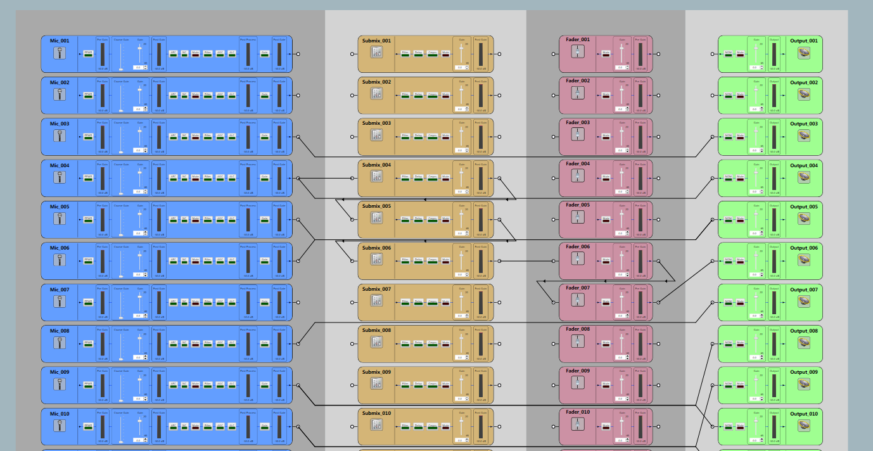
This figure illustrates the minimum set of objects and rendering map for relative positions of source End point, two types of processing blocks (P-Block & Fader), and then the final destination End point objects. Note: Routing must allow unrestricted routing (left and right) between the processing blocks.
This illustration is “Object” oriented: The relative position of the Objects does not change … the Lines must be routed around them. In a “Route/Line” oriented illustration, the lines are simplified and the Object are moved to accommodate the “straightest and simplest” display of the routes/lines.
Figure 2

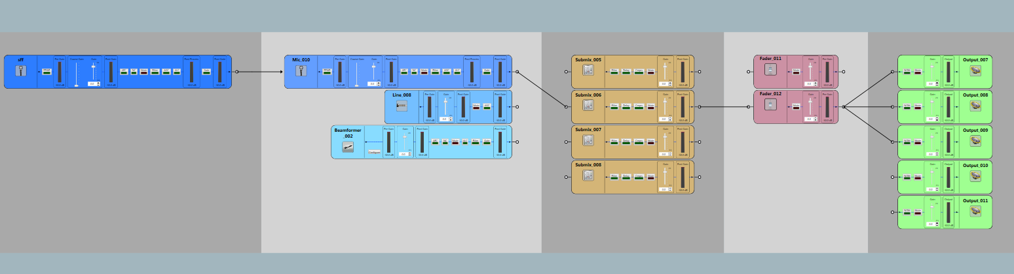
Groups illustrated as Objects that extend the map. A group is a named and references to a set of homogeneous objects.

Figure 3

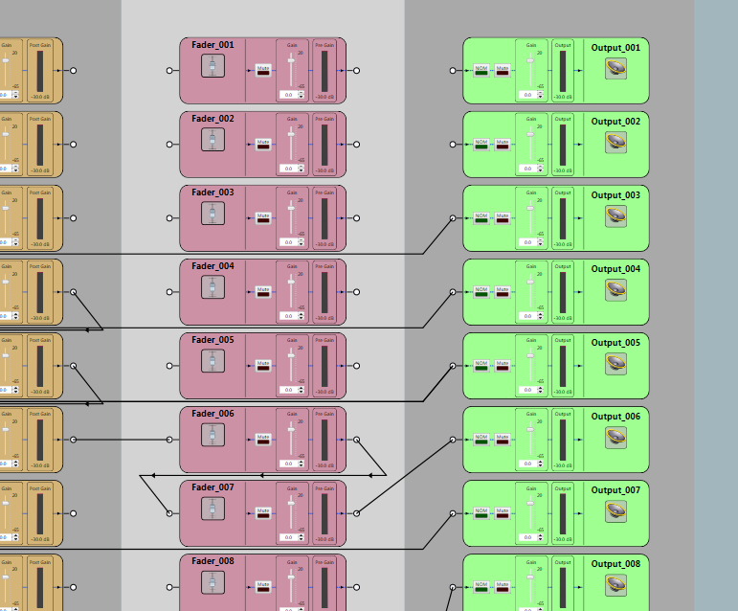

Figure 4
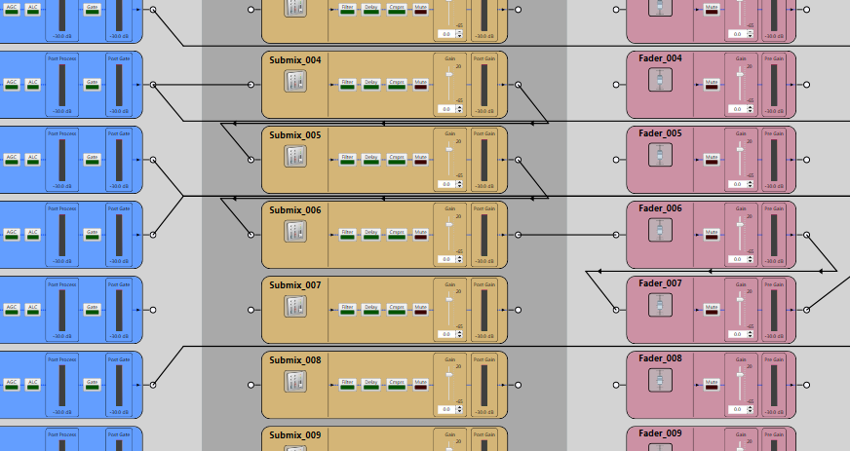
Figure 5
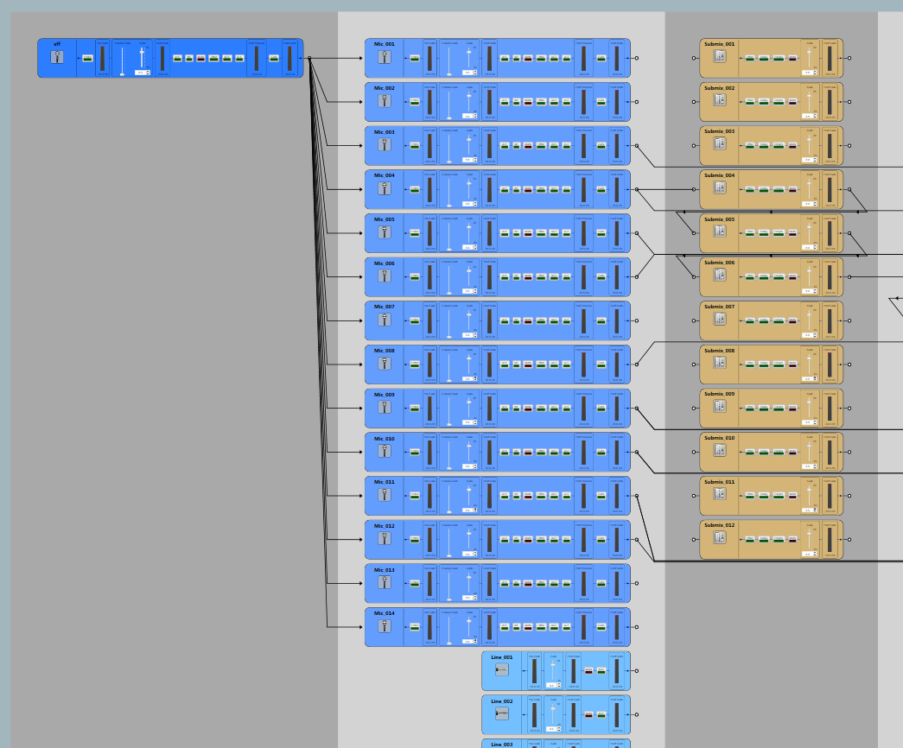
Figure 6
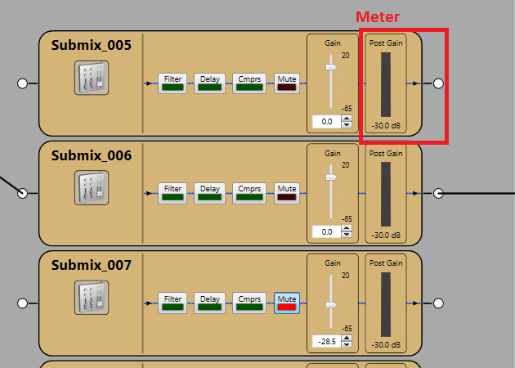
Figure 7
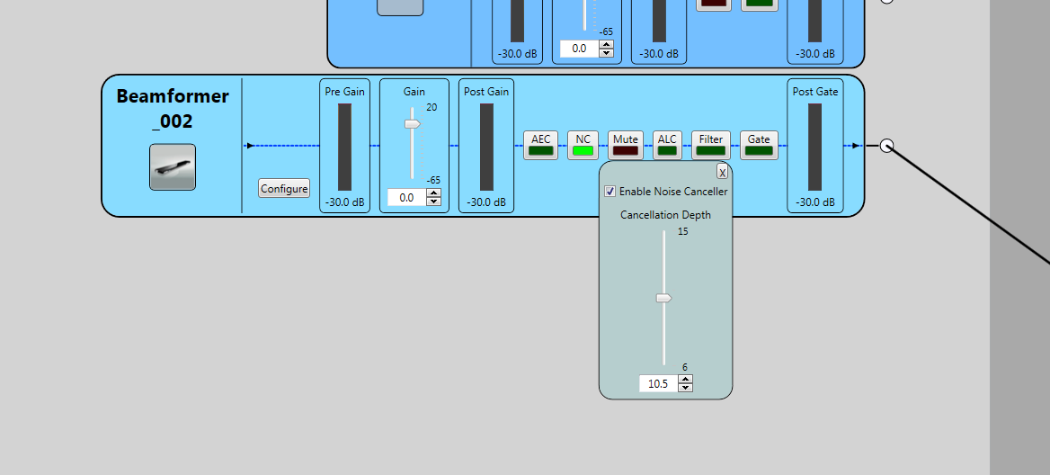
Figure 8

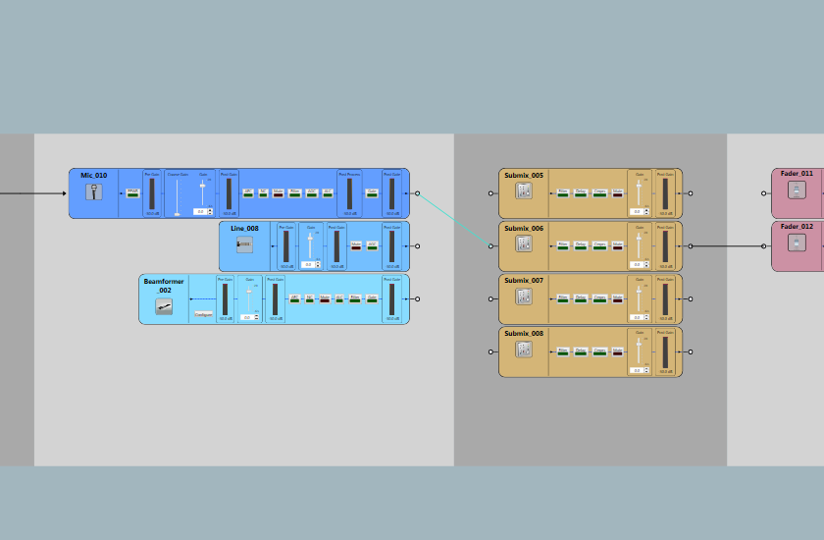

Appendix A : Audio Routing Matrix

